1. Open File Explorer on your task bar.

2. In File Explorer, find the file or folder you want to share. Then, right click on it. When you do this, a drop-down menu will appear. Click to 'Share'.
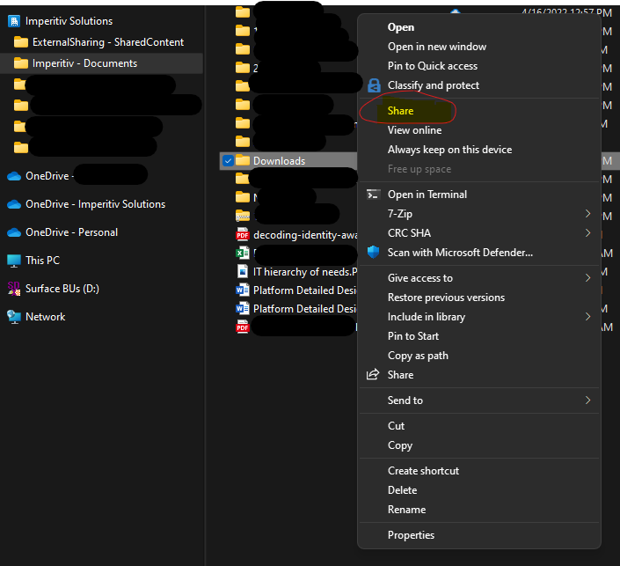

3. The following pop-up will appear. Click on the 'People you specify can view' button (it may have different wording based on your setup).
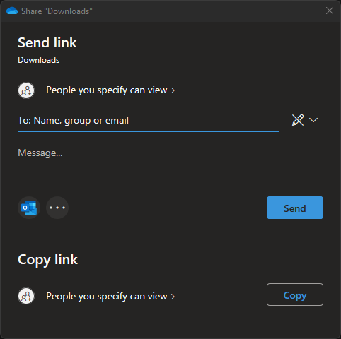
4. Now you can decide which sharing settings you'd like to use (it will have your company name not Imperitiv).
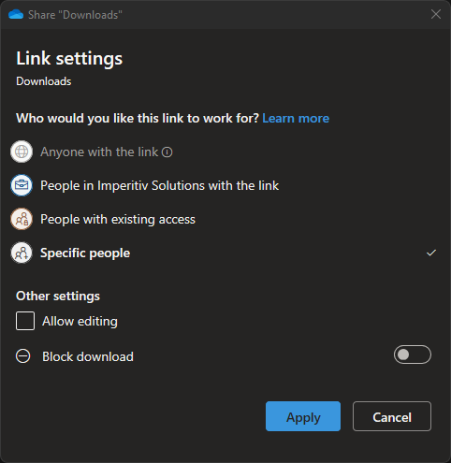
- Anyone with the link: This allows anyone who has the link to access it.
- People in “Your Company Name” with the link: This allows anyone within your company who has signed in with their company account to access it.
- People with existing access: This allows anyone who has access to the whole site to access it. This is manly used if you just want to direct someone to a file or folder and not grant new access.
- Specific people: Only people you choose can access it. You’ll need to key in their whole email address if they are external. If they are internal, then you only need to type enough of their name to have them auto-populate.
You can also check/uncheck the “Allow editing” option to provide read-only or edit access to the file/folder, and to block downloading of the file if you allow editing (if you allow editing, you cannot block the download at this level).
6. When you're done, click 'Apply'.

7. If you wish to send a message, click in the “Message…” area and type your message. When finished you can click “Send”. However, see the next step
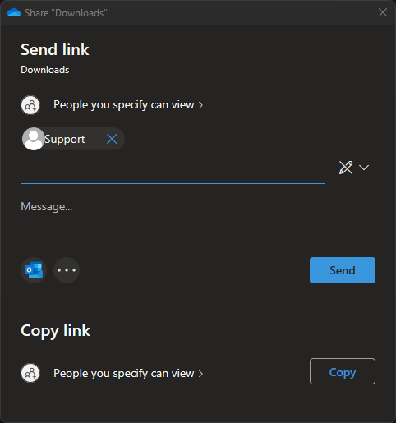

8. The email sent from the step above may look like spam to the recipient with this method. It's recommended that you open your own email account, create a new email and send the link from there to your desired recipients instead.
To do this, click the Copy button and you’ll get a window like the one below. Click the new “Copy” button and paste the link into an email you generate from Outlook manually. Once you send the email you’ve completed the steps necessary to share your files/folders from SharePoint
